Summer MGMT 59000: AI-Assisted Big Data Analytics in the Cloud

**Assignment 1: Team Collaborative Analysis**

**Using Cloud Data Lakes for Business Intelligence**

Role: **Sales & Revenue Analyst**

Name: Michael Yudanin, [myudanin@purdue.edu](mailto:myudanin@purdue.edu)

Insights summary

Customer’s **city** and product **brand**

have the most impact on sales

* **Focus on the most productive   
  cities and brands**

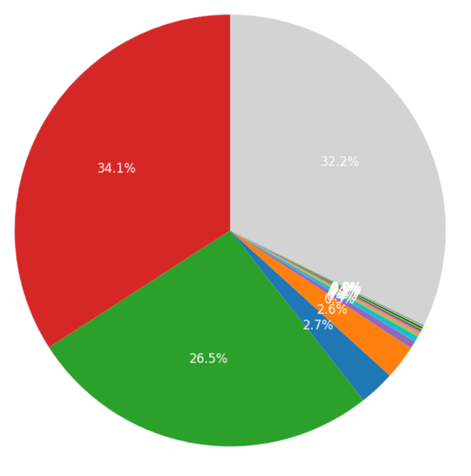

**CITY**

**BRAND**

**Champion customers** buy more

* **Focus on your champions**



**Discounts are not your best bet**: they drive sales but shrink profits

* **Don’t sweat over discounts, look elsewhere**

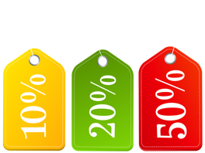

**Higher unit prices** drive increased sales

* **Focus on higher-priced products**



Do more research:

* Try to understand why **cities and brands** matter so much
* The **impact of seasonality** is inconclusive: look into it
* Use **Machine Learning** models to predict sales